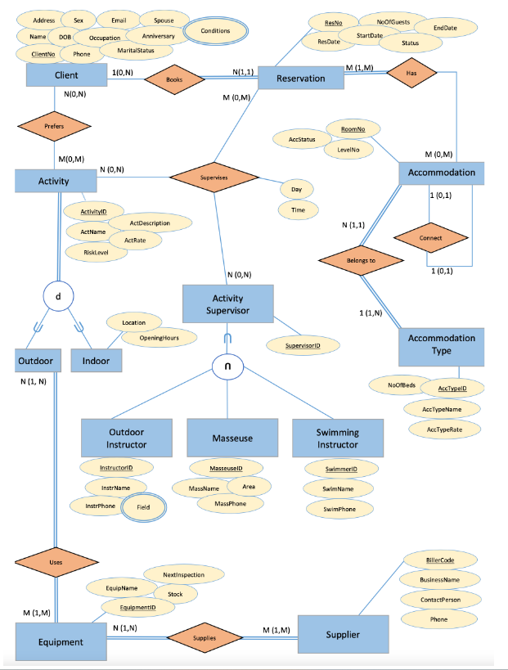Assignment 2 CSE4DBF Michael Le

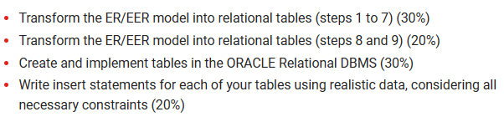

**Task 1**

**Step 1 Regular Entities, Mapping of Regular Entity Types (include superclasses)**

Client (CilentNo, Phone, Martial Status, Anniversary, Spouse, Occupation, Email, DOB, Sex, Name, Address)

Reservation (ResNo, ResDate, StartDate, NoOfGuests, Status, EndDate)

Accommodation (RoomNo, AccStatus, LevelNo)

Accommodation_Type (AccTypeID, NoOfBeds, AccTypeName, AccTypeRate)

Activity (ActivityID, AccName, RiskLevel, ActRate, ActDescription)

Outdoor_Instructor (InstructorID, instrName, instrPhone)

Masseuse (MasseuseID, MassName, Area, MassPhone)

Swimming_Instructor (SwimmerID, SwimName, SwimPhone)

Equipment (EquipmentID, EquipName, Stock, NextInspection)

Supplier (BillerCode, BusinessName, ContactPerson, Phone)

**Step 2 Weak Entries**

No Weak relationships

**Step 3 1:1 relationships**

No 1:1 Relationships

**Step 4 1: N relationships**

Reservation (ResNo, ResDate, StartDate, NoOfGuests, Status, EndDate)

Accommodation (RoomNo, AccStatus, LevelNo)

**Step 5 M: N relationship**

Has_ Accommodation (ResNo, RoomNo)

Supplies (EquipmentID, BillerCode)

Cilent_Uses (EquipmentID)

**Step 6 Multi-valued attribute**

Client_Cond (CilentNo, Conditions)

Outdoor_Field (InstructorID, Field)

**Step 7 n-ary relationship (N>2)**

Supervises (ActivityID, ResNo, SupervisorID, Day, Time)

**Step 8 Specialisation/generalisation relationship**

For the purposes of outlining what each of the options mean, we present all four options (8A, B, C, and D) here. But for every specialisation, we must select ONE.

**Step 8a N relations: superclass + subclasses work for any specialisation total, partial, disjoint, overlapping.**

Activity (ActivityID, AccName, RiskLevel, ActRate, ActDescription, CilentNo, ResNo, SupervisorID)

Outdoors (ActivityID)

Indoors (ActivityID, Location, OpeningHours)

**Step 8b N relations: subclasses only (if the specialisation is overlapping)**

Outdoors (ActivityID, AccName, RiskLevel, ActRate, ActDescription, CilentNo, ResNo, SupervisorID)

Indoors (ActivityID, Location, OpeningHours, AccName, RiskLevel, ActRate, ActDescription, CilentNo, ResNo, SupervisorID)

**Step 8c 1 relation + 1 type attribute only works if (only for a specialisation whose subclasses are disjoint and has the potential for generating many NULL values if many specific attributes exist in the subclasses.)**

Activity (ActivityID, AccName, RiskLevel, ActRate, ActDescription)

**Step 8d 1 relation + N type attributes works only if (This option works for a specialisation whose subclasses are overlapping (but will also work for a disjoint specialisation))**

Activity (ActivityID, AccName, RiskLevel, ActRate, ActDescription, isOutside, isInside, Location, OpeningHours)

NOTE: isOutside and isInside are Boolean type fields

**After completing Step 8a Repeating Steps 2- 7**

**Step 2**

No Weak relationships

**Step 3**

No 1:1 Relationships

**Step 4**

No 1: N Relationships

**Step 5**

Cilent_Uses (ActivityID, EquipmentID)

**Step 6**

No Multivalued attributes

**Step 7**

Supervises (ActivityID, ResNo, SupervisorID, Day, Time, AccName, RiskLevel, ActRate, ActDescription, CilentNo, ResNo, SupervisorID)

**After completing Step 8b Repeating Steps 2- 7**

**Step 2:**

No Weak relationships

**Step 3:**

No 1:1 Relationships

**Step 4:**

No N:1 relationships

**Step 5:**

Cilent_Uses (ActivityID, EquipmentID)

**Step 6:**

No Multivalued attributes

**Step 7:**

No n-ary relationships

**After completing Step 8c Repeating Steps 2- 7**

**Step 2:**

No Weak relationships

**Step 3:**

No 1:1 Relationships

**Step 4:**

No 1: N Relationships

**Step 5:**

No M: N Relationships

**Step 6:**

No Multivalued attributes

**Step 7:**

Supervises (ActivityID, ResNo, SupervisorID, Day, Time, AccName, RiskLevel, ActRate, ActDescription, Location, OpeningHours)

**After completing Step 8d Repeating Steps 2- 7**

**Step 2:**

No Weak relationships

**Step 3:**

No 1:1 Relationships

**Step 4:**

No 1: N Relationships

**Step 5:**

No Weak relationships

**Step 6:**

No Multivalued attributes

**Step 7:**

Supervises (ActivityID, ResNo, SupervisorID, Day, Time, AccName, RiskLevel, ActRate, ActDescription, Location, OpeningHours, isOutside, isInside)

**Step 9 Category/Union Type relationship**

Activity_Supervisor (SupervisorID)

Outdoor_Instructor (InstructorID, instrName, instrPhone, SupervisorID)

Masseuse (MasseuseID, MassName, Area, MassPhone, SupervisorID)

Swimming_Instructor (SwimmerID, SwimName, SwimPhone, SupervisorID)

**After completing Step 9 Repeating Steps 2- 7**

**Step 2:**

No Weak relationships

**Step 3:**

No 1:1 Relationships

**Step 4:**

No 1: N Relationships

**Step 5:**

No M: N Relationships

**Step 6:**

Outdoor_Instructor (InstructorID, Field, instrName, instrPhone, SupervisorID)

**Step 7:**

Supervises (ActivityID, ResNo, SupervisorID, Day, Time)

**FINAL TABLES**

NOTE: ***foreign keys (*italicised*)***

Client (CILENTno, Phone, Martial Status, Anniversary, Spouse, Occupation, Email, DOB, Sex, Name, Address) **(Step 1) (DONE)**

Reservation (RESno, RESDate, StartDate, NoOfGuests, Status, EndDate) **(Step 1) (DONE)**

Accommodation (ROOMno, AccStatus, LevelNo) **(Step 1) (DONE)**

Accommodation_Type (ACCTYPEid, NoOfBeds, AccTypeName, AccTypeRate) **(Step 1) (DONE)**

Equipment (EQUIPMENTid, EquipName, Stock, NextInspection) **(Step 1) (DONE)**

Supplier (BillerCode, BusinessName, ContactPerson, Phone) **(Step 1) (DONE)**

Has_ Accommodation (RESno, ***ROOMno***) **(Step 5) (DONE)**

Supplies (EQUIPMENTid, ***BillerCode***) **(Step 5) (DONE)**

Client_Cond (CILENTno, Conditions) **(Step 6) (DONE)**

Outdoor_Field (INSTRUCTORid, Field) **(Step 6) (DONE)**

Activity_table (ACTIVITYid, AccName, RiskLevel, ActRate, ActDescription, ***CILENTno***, ***RESno***, ***SUPERVISORid***) **(Step 8A) (DONE)**

Cilent_Uses (EQUIPMENTid, ***ACTIVITYid***) **(Step 8A) (DONE)**

Indoors (ACTIVITYid, Location, OpeningHours) **(Step 8A) (DONE)**

Outdoors (ACTIVITYid) **(Step 8A) (DONE)**

Supervises (SUPERVISORid***, ACTIVITYid***, ***RESno***, Day, Time, AccName, RiskLevel, ActRate, ActDescription, Location, OpeningHours, isOutside, isInside ) **(Step 8A-8D add isOutside and isInside as BOOLEAN) (DONE)**

Activity_Supervisor (SUPERVISORid) **(Step 9) (DONE)**

Masseuse (MASSEUSEid, MassName, Area, MassPhone, ***SUPERVISORid***) **(Step 9) (DONE)**

Swimming_Instructor (SWIMMERid, SwimName, SwimPhone, ***SUPERVISORid***) **(Step 9) (DONE)**

Outdoor_Instructor (INSTRUCTORid, Field, instrName, instrPhone, ***SUPERVISORid***) **(Step 9) (DONE)**

**TASK 2 CREATING THE TABLES IN ORACLE APEX**

DROPPING TABLES

DROP TABLE <tablename>;

**NOTE:** RUNNING THE TABLE WITH THE SAME NAME CAN NOT CREATE A NEW TABLE.

**CREATE TABLE ACCOMMODATION(**

**ROOMno NUMBER NOT NULL,**

**ACCSTATUS CHAR(8) NOT NULL,**

**LEVELNO NUMBER(2),**

**PRIMARY KEY(ROOMno)**

**);**

**CREATE TABLE ACCOMMODATION_TYPE(**

**ACCTYPEid VARCHAR2(5) NOT NULL,**

**NO_OF_BEDS NUMBER(2),**

**ACCTYPENAME VARCHAR2(25) NOT NULL,**

**ACCTYPERATE NUMBER(3) NOT NULL,**

**PRIMARY KEY(ACCTYPEid)**

**);**

**CREATE TABLE ACTIVITY_SUPERVISOR(**

**SUPERVISORid VARCHAR2(5) NOT NULL,**

**PRIMARY KEY (SUPERVISORid)**

**);**

**CREATE TABLE ACTIVITY_TABLE(**

**ACTIVITYID VARCHAR2(5) NOT NULL,**

**CILENTno NUMBER NOT NULL,**

**RESno NUMBER NOT NULL,**

**Supervisorid VARCHAR2(5) NOT NULL,**

**ACCNAME VARCHAR2(50),**

**RISKLEVEL CHAR(1),**

**ACTRATE NUMBER(2),**

**ACTDESCRIPTION VARCHAR2(100),**

**PRIMARY KEY (Activityid),**

**FOREIGN KEY (Cilentno) REFERENCES CILENT (CILENTno),**

**FOREIGN KEY (Resno) REFERENCES RESERVATION (RESno) ,**

**FOREIGN KEY (Supervisorid) REFERENCES ACTIVITY_SUPERVISOR(SUPERVISORid)**

**);**

**CREATE TABLE CILENT(**

**CILENTno NUMBER NOT NULL,**

**FULLNAME VARCHAR2(50) NOT NULL,**

**PHONE VARCHAR2(13) NOT NULL,**

**MATRIAL_STATUS NVARCHAR2(20),**

**ANNIVERSARY DATE,**

**SPOUSE VARCHAR2(50),**

**OCCUPATION VARCHAR2(30),**

**EMAIL VARCHAR2(30) NOT NULL,**

**DOB DATE NOT NULL,**

**SEX CHAR(2),**

**ADDRESS VARCHAR2(50) NOT NULL,**

**PRIMARY KEY(CILENTno)**

**);**

**CREATE TABLE CILENT_COND(**

**CILENTid VARCHAR2(5) NOT NULL,**

**CONDITIONS VARCHAR2(20),**

**PRIMARY KEY (CILENTid)**

**);**

**CREATE TABLE CILENT_USES(**

**EQUIPMENTid VARCHAR2(5) NOT NULL,**

**ACTIVITYid VARCHAR2(5) NOT NULL,**

**PRIMARY KEY (EQUIPMENTid),**

**FOREIGN KEY (ACTIVITYid) REFERENCES Activity_table(ACTIVITYid)**

**);**

**CREATE TABLE EQUIPMENT(**

**EQUIPMENTid VARCHAR2(5) NOT NULL,**

**EQUIPNAME VARCHAR2(30) NOT NULL,**

**STOCK NUMBER,**

**NEXTINSPECTION CHAR(15),**

**PRIMARY KEY(EQUIPMENTid)**

**);**

**CREATE TABLE HAS_ACCOMMODATION(**

**RESno NUMBER NOT NULL,**

**ROOMno NUMBER NOT NULL,**

**PRIMARY KEY(RESno),**

**FOREIGN KEY (ROOMno) REFERENCES ACCOMMODATION(ROOMno)**

**);**

**CREATE TABLE INDOORS(**

**ACTIVITYid VARCHAR2(5) NOT NULL,**

**OpeningHours DATE NOT NULL,**

**LOCATION VARCHAR2(30) NOT NULL,**

**PRIMARY KEY (ACTIVITYid)**

**);**

**CREATE TABLE MASSEUSE(**

**MESSEUSEid VARCHAR2(5) NOT NULL,**

**Supervisorid VARCHAR2(5) NOT NULL,**

**MASSNAME VARCHAR2(30) NOT NULL,**

**AREA VARCHAR2(20),**

**MASSPHONE VARCHAR2(13) NOT NULL,**

**PRIMARY KEY (MESSEUSEid),**

**FOREIGN KEY (Supervisorid) REFERENCES SUPERVISES(SUPERVISORid)**

**);**

**CREATE TABLE OUTDOORS(**

**ACTIVITYid VARCHAR2(5) NOT NULL,**

**PRIMARY KEY (ACTIVITYid)**

**);**

**CREATE TABLE OUTDOOR_FIELD(**

**INSTRUCTORid VARCHAR2(5) NOT NULL,**

**Field VARCHAR2(25),**

**PRIMARY KEY (INSTRUCTORid)**

**);**

**CREATE TABLE OUTDOOR_INSTRUCTOR(**

**INSTRUCTORid VARCHAR2(5) NOT NULL,**

**Supervisorid VARCHAR2(5) NOT NULL,**

**instrName VARCHAR2(30) NOT NULL,**

**instrPhone VARCHAR2(13) NOT NULL,**

**Field VARCHAR2(25),**

**PRIMARY KEY (INSTRUCTORid),**

**FOREIGN KEY (Supervisorid) REFERENCES SUPERVISES(SUPERVISORid)**

**);**

**CREATE TABLE RESERVATION(**

**RESno NUMBER NOT NULL,**

**RESDATE DATE NOT NULL,**

**STARTDATE DATE NOT NULL,**

**NO_OF_GUESTS NUMBER(2),**

**STATUS VARCHAR2(10),**

**ENDDATE DATE NOT NULL,**

**PRIMARY KEY(RESno)**

**);**

**CREATE TABLE SUPERVISES(**

**SUPERVISORid VARCHAR2(5) NOT NULL,**

**ACTIVITYid VARCHAR2(5) NOT NULL,**

**RESno NUMBER NOT NULL,**

**Risklevel CHAR(1),**

**DATE_TIME DATE NOT NULL,**

**DATE_DAY DATE NOT NULL,**

**ActRate NUMBER(2),**

**AccName VARCHAR2(25) NOT NULL,**

**ActDescription VARCHAR2(100),**

**LOCATION VARCHAR2(30) NOT NULL,**

**OpeningHours DATE NOT NULL,**

**PRIMARY KEY (SUPERVISORid),**

**FOREIGN KEY (ACTIVITYid) REFERENCES ACTIVITY_TABLE(ACTIVITYid),**

**FOREIGN KEY (RESno) REFERENCES RESERVATION(RESno)**

**);**

**CREATE TABLE SUPPLIER(**

**BILLERCODE NUMBER(6) PRIMARY KEY,**

**BUSINESSNAME VARCHAR2(30) NOT NULL,**

**CONTACTPERSON VARCHAR2(30) NOT NULL,**

**PHONE VARCHAR2(10) NOT NULL**

**);**

**CREATE TABLE SUPPLIES(**

**EQUIPMENTid VARCHAR2(5) NOT NULL,**

**BILLERCODE NUMBER(6) NOT NULL,**

**PRIMARY KEY (EQUIPMENTid)**

**);**

**CREATE TABLE SWIMMING_INSTRUCTOR(**

**Supervisorid VARCHAR2(5) NOT NULL,**

**SWIMMERid VARCHAR2(5) NOT NULL,**

**SWIMNAME VARCHAR2(30) NOT NULL,**

**SWIMPHONE VARCHAR2(13) NOT NULL,**

**PRIMARY KEY (SWIMMERid),**

**FOREIGN KEY (Supervisorid) REFERENCES SUPERVISES(SUPERVISORid)**

**);**

**TASK 2 WRITING INSERT STATEMENTS**